FITNESS WEBSITE
A fitness website is a place to introduce people to the fitness parlor, the philosophy, and any special focuses. Besides these, a site can achieve so much more. With the right tools, it helps to manage a schedule, appointments, and payments. It is also powerful in creating a community and engaging clients.

WHERE TO FIND A FITNESS WEBSITE?
There are a lot of great places where you can reach the Fitness website today. These websites have free accesses that provide information based on any Fitness and Gym websites. Fitness websites are also available for any person to help them.
- Planet Fitness
- Livestrong Fitness
- LA Fitness
- Men’s Health
- Muscle & Fitness

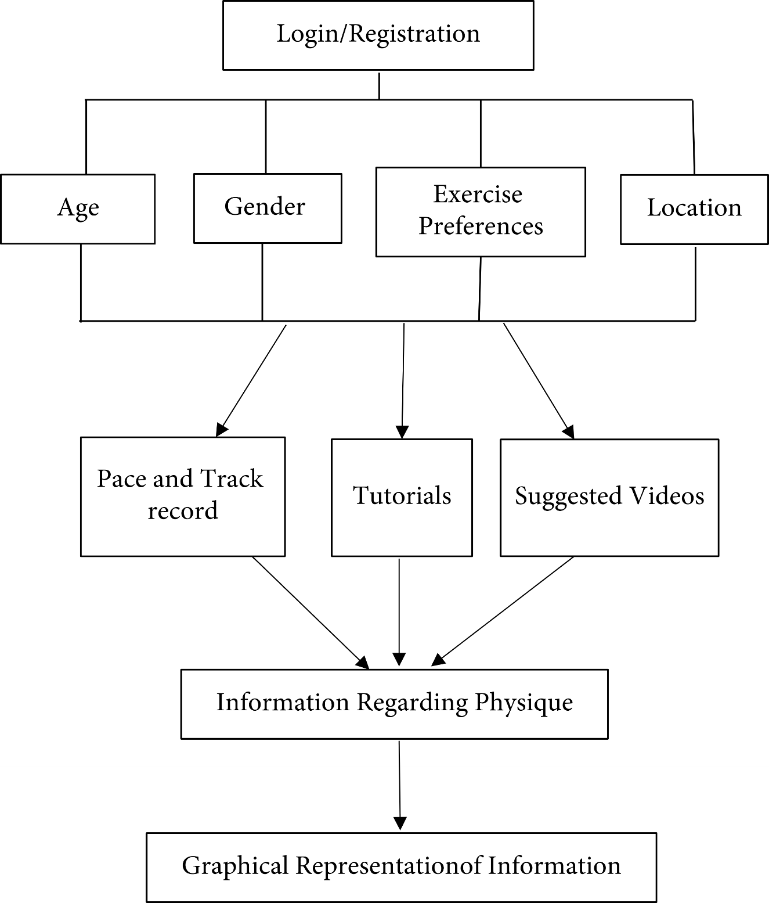

ADVANTAGES OF FITNESS WEBSITES:
- Having a website for your fitness center is a great way to reach people who may not know about you. When someone searches the internet and finds your website, they’ll see all the benefits that come with working out at your gym-whether it’s having access to personal trainers or on-site childcare. This could lead them to sign up for one of your offered classes and eventually become a member of your gym if they don’t live close to the area- no problem because they’re able to sign up online and get access to all your classes, from anywhere in the world!

- Promote Your Services and Educate Potential Clients About What You Offer With your website always available for them to look at and browse, you’re able to promote your services and educate potential clients about what they can expect from working out with you. This is especially useful when people decide on a new gym or whether they should switch gyms in the first place! You can also promote free or discounted classes to find it easier for people trying out working out at your gym. They’ll get all the benefits without paying for an arm and a leg right away. Just make sure that all the services that your gym can offer are easy to find.

- Because of websites, businesses can now take advantage of reaching more people with their products and services than ever before! Anyone can visit a website from any device on hand, including tablets, laptops, or smartphones. This makes it so much easier for your marketing campaign to see as many potential customers as possible. A fitness website can promote individual health and wellness and help strengthen communities by promoting an active lifestyle that invites all members. Another great thing about websites for fitness studios is that they are inexpensive to set up and maintain. So even if you were a new business, you would still afford this website to advertise your products or services.
THE FITNESS WEBSITE LOOKS LIKE THIS:


CODES:
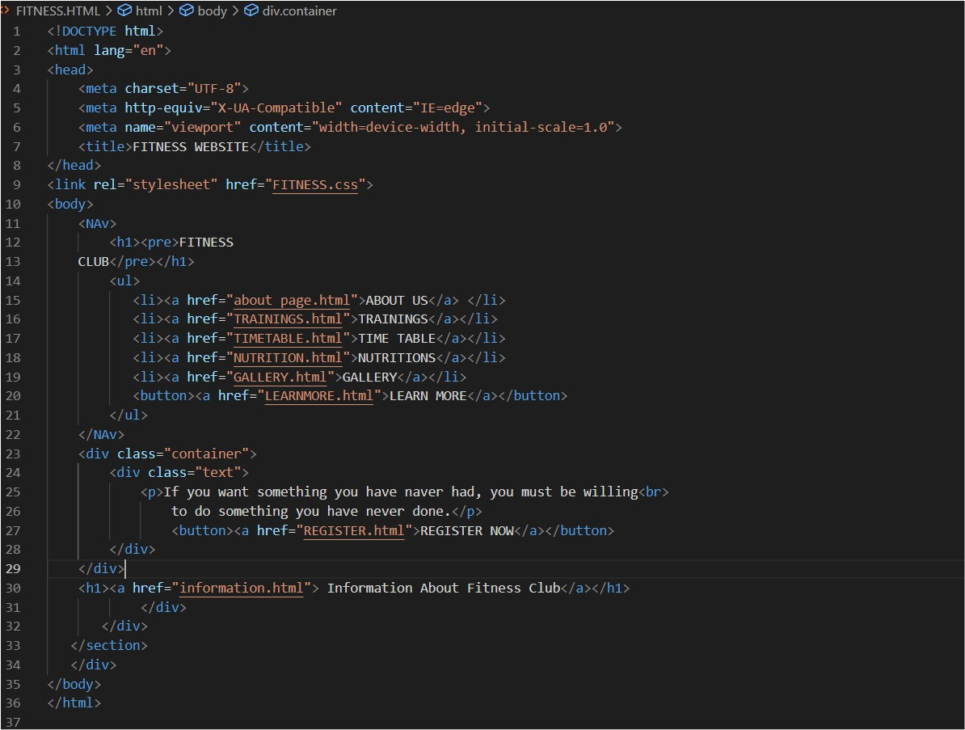
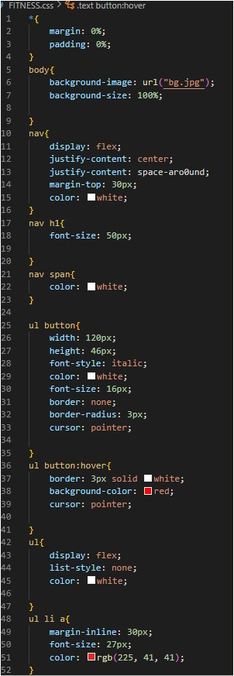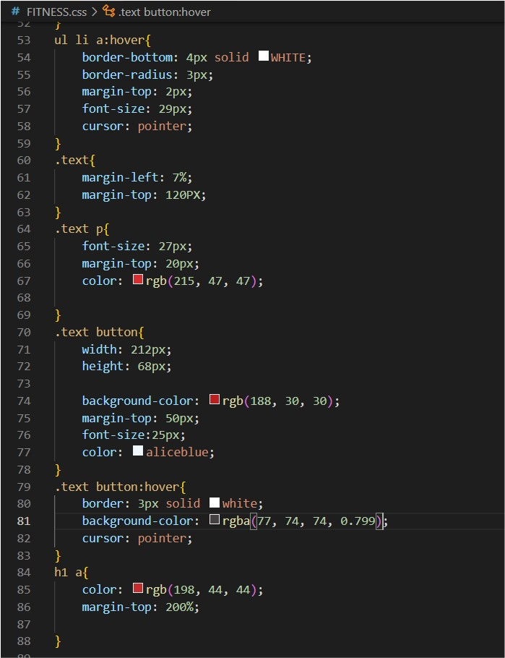

ABOUT OUR FITNESS WEBSITE:
- For This website, you need to register first with sign up with your Gmail or Phone number and make a good password for this website so only this website is only accessible to you and your close ones.
- In the login section, they can only ask you for a username and password.
- In the home section, you can know only about that education system or websites.
- Gives sometimes of yours on these websites because you know about us and what we did here and visit once in this Fitness club.

PROJECT = CSE326
Project created by: Raju Kumar Anand, And Shambhu Saran Singh
REG.NO:12211009, 12214392: Raju Kumar Anand Shambhu Saran Singh
TEACHER: DR. MOHAMMAD FAIZ

